**Floated elements: margin never collapse**

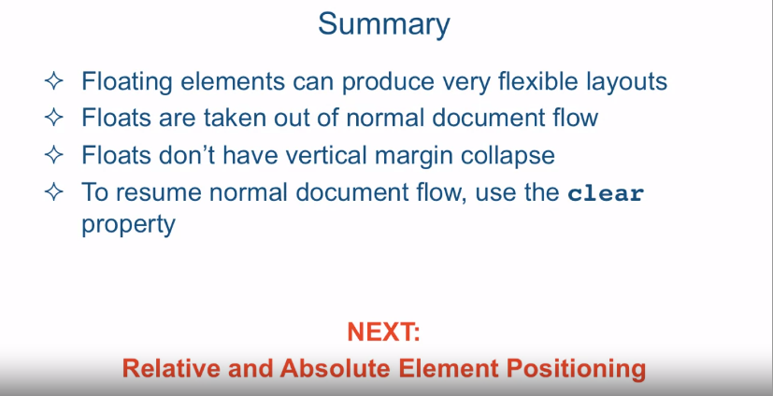

[SOUND] In this lecture we're going to talk about

positioning elements by floating them. Now knowing how to properly float elements

is an essential skill to have, and this is partially because most of the UIs

today, web UIs today that are made, are made by floating the elements. In fact, by the end of this lecture, we're

going to create a two column flexible design where the columns will be flexible

as we expand and contract the browser. So let's jump into the code editor and

see how this works. Okay, so we are in sublime text and we're looking at the file named

floating before that HTML. So let's go over the structure of

this HTML document real quick. We have our regular h1 here just

to announce what that is, and then we have a div with

four paragraph tags and a section tag with some text in it, and

the paragraph tags ID p1, p2, p3, p4. If you look at our div section,

we styled the div tag, its background to be a certain color. Basically a light bluish color, and

every single paragraph tag was styled to be 50 pixels wide and 50 pixels tall,

and we gave it a nice one pixel border. And just to differentiate

between each paragraph box, we gave it a different

background color to each one. So let's go ahead and take a look at

what this looks like in the browser. Okay, so here are the four

paragraph boxes that we had. Okay, so let's go ahead and float the very

first paragraph box to the right. We'll say, float: right, and we'll go

ahead and refresh the page, and you see that the box jumped all the way to the

right, top edge of the containing element. Now, a couple of quick

things to notice right away. First, is that you could see that the rest

of them moved up as if the maroon box isn't there anymore. And the reason this is happening is

because when you float elements, the browser takes them out of

the regular document flow. And this is why the second paragraph box

moves into the original spot of the first one, because as far as the regular

document flow is concerned, that spot became empty. Second thing to notice is that even

though each one of these paragraph boxes has a margin around them, as you can

see that there's a margin between each one of them right here, that margin

collapses as we've learned before when it is touching the margin

of another element. However, when it comes to floated

elements, the margins never collapse. And this is why you now seeing

the margin around the element on top. Also, if you paid close attention,

you will notice that the blue, light blue box,

the development became shorter. To really illustrate what's going on,

let's go ahead and remove the float right, and instead make every single

paragraph box float to the left. And to ensure that the boxes aren't

squished right against the other, let's go ahead and

give it a margin-right of let's say 10 px. Let's go ahead and refresh the page and

you could see that now they're all floated to the left and

there's a ten pixel margin between them. However, what happened to our div? Our div seemed to have completely

collapsed and the only thing that's really keeping it open at all is

the text that we've put in here. This is happening because of

the same point that I made before. When you float elements it takes them

out of the regular document flow, therefore it collapses and hide, and surrounds the last section element

which has actually some text in it. In order to correct it,

we need to tell the browser that when it comes to this section element, the browser

should resume the regular document flow. And the way that we do that is

by using the clear property. So let's go ahead and go to our

styling and define section target and wel say, clear: left. And what this is doing is telling

the browser that the section element is announcing that nothing should be allowed

to be floating to the left of it. And since every single paragraph that

we've been floating is floating to the left, when we save it and refresh, this should jump right

below here, and so it does. And this is not restricted

to the non floated elements. We can ask a floated element to

resume its regular document flow, and then float it again. So for example, the reason this box is

situated right here is because there's something already floated

to the left of it, but if I tell the browser to go ahead and

resume the regular document flow on it, it should jump to the next line and

then resume floating from there on. So that's box number three, so let's go

ahead and go over here and say clear, and since things are floated to the left of

the box, we're going to say clear: left, so nothing should be allowed

to flow to the left of it. We save and refresh, you can now see that box number three moved in its own line

again and is floated to the left again. There's one more value of the clear

property that I should explain before we move on to try to create our two

column layout, and that value is both. So you could say clear both. So let me show you a circumstance

where that would actually apply. We're going to reset our page back to

the way it was, and we'll go ahead and remove the floating elements here,

and we'll refresh, so this is how it was when we started. So let's go ahead and float the first

element to the left as we did before, and we'll float the second

box to the right. Okay, so now if we refresh the browser

you can see that both boxes floated, and you can see the other two

kind of moved into their places. So we already know how to deal with that. In order to move them to the next line,

we can just say clear. And now we need to clear what? Now there's a box floating to the left and

there's a box floating to the right, so we can say clear: right. And when we refresh the browser

this will go on it's own line. However, we can equally

say clear:left because there's a box that is on the left as well. So it seems like in this

particular circumstance, it doesn't make any difference

whether you say left or right. However, it will make a difference if

I make the right box much taller than it is now. So I'll go ahead and

go to box number two, and I'll make its height something

much taller, let's say 300 pixels. When I refresh the page, you could see

that it really went all the way down and it's totally ignoring the fact

that I want to clear this element, meaning I want it really

on the next line by itself. And the reason it's happening is because

I'm actually clearing this element only from the left floating elements, but I'm not clearing it from

the right floating elements. So therefore, if I wanted to,

I could say here, clear: right, again and when I refresh,

it will jump all the way down. But the problem is, is that what happens

when this element becomes too tall? Well, then it will start

overlapping again, right? So if I make this element, let's make

a little bit less, let's make it 100. And when we refresh you can see now,

it's still not overlapping because we're clearing to the right but

lets now make element number one polar, lets make it's height say 150 pixels and

refresh you can see now it's overlapping. So, in order to ensure that both columns,

or both left and right Floated elements are not encroaching

on our space here of the third element. We could just say, clear both. And refresh you could see that no

matter which one is going to be taller it will still insist that nothing

should be floated to its left or to its right, and

therefore it will be on it's own line. Okay, so let's go ahead and try to

achieve that two column layout design. And in order to do that we're going to

take a look at a file called two column before that html and it's located in

the same folder, examples lecture 21. An HTML structure is basically very

similar to the file we just looked at. The differences here is that I only

have two paragraph tags inside that div, I removed the other two, and we still

have a a section tag inside of it. And what we want to achieve is that this

first paragraph should be left column and the second paragraph should

be the right column. So let's see what we did here. So first of all, for now, we're keeping

the background colors of all the elements. And on the paragraph tag we said

the width, and the width we did something different this time, we didn't

specify pixels, we specified percent. So we're saying the width should be

50% of its containing element, and the containing element is the div. Well, the div is a block level element, so

it tries to fill in the entire width of its containing element,

which is the body or the entire browser. So basically what we're saying is that

a paragraph should take 50% of the entire view port. We'll also give it a one pixel border and

we floated each one of them to the left. So let's go ahead and take a look at the

browser to see what this turned out to be. And looking at the browser,

not quite exactly what we wanted. The second paragraph is

still on the bottom. Why is this happening? Well, the reason this is happening is

because we're still using the default box sizing, which is content box. Then we're saying that we want

the box to take 50% of the screen and then we're adding that one pixel border,

that really breaks the whole thing. So if we remove that pixel right here, and refresh the browser,

now it's floating exactly how we want it. And by the way, this is a great

illustration of what happens to floated elements when they can't

fit on the same line. And what happens is they

float to the next line. And this is actually what happened when

we had the border pushing the size of the box a little bit too much that

it didn't fit on the same line anymore. However for now we do want the border, and if we get the border then we can't have

the floating, so how do we fix this? Well hopefully you still remember

how to reset the box-sizing, and the box-sizing we're

going to say is border-box. And once we do that, the border will

be included in the 50% of the width, so now we save the file,

we go ahead and refresh, and now we see even with the border we can

have both of them floating side by side. Let's enhance out layout a little

bit by giving some padding to the content inside each paragraph. So let's say padding of,

let's give it 10 px all around. Let's refresh and we can see now that

we have the content separated from its border a little bit better. And finally we can actually remove

all of these background colors and the border because they were only

there to help us visualize things, so we're going to go ahead and

comment them out and refresh, and

now we see we have a two column layout. Let's make this a little bit bigger,

and as you can see now, the layouts have a two column layout,

and as I squeeze the browser, the two column layout stays, and

not only that, they're flexible. And the reason they're flexible is because

we didn't specify them with a particular pixel size, we specified them as

a percentage of its container element. So in summary, floating elements

can produce very flexible layouts. Floats are taken out of their

normal document flow, and they're positioned at the top left or

right edge of the containing element. Also, floats don't have

vertical margin collapse, so previously hidden or collapsed margins

will show up once you float the element. And remember that to resume normal

document flow, use the clear property. Either clear left,

clear right or clear both. Next, we're going to talk about relative

and absolute element positioning.